Table 7.4
Calculate the following:
- μx = 3.5666
- σx = 2.1657

Size = 5
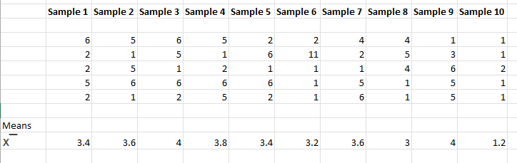
- x¯= 3.32
- sx¯ = 2.289

Size = 10

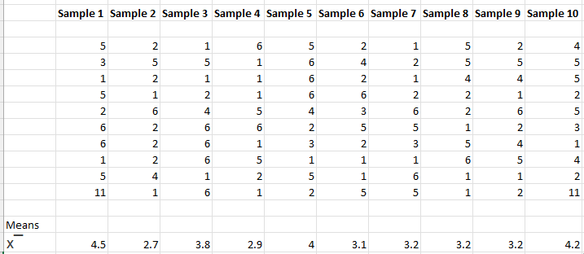

- x¯= 3.48
- sx¯ = 2.178
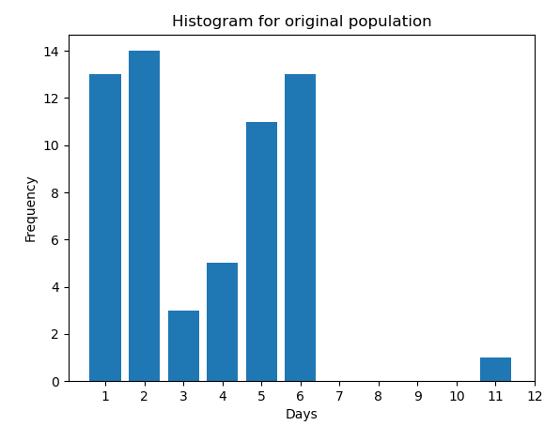

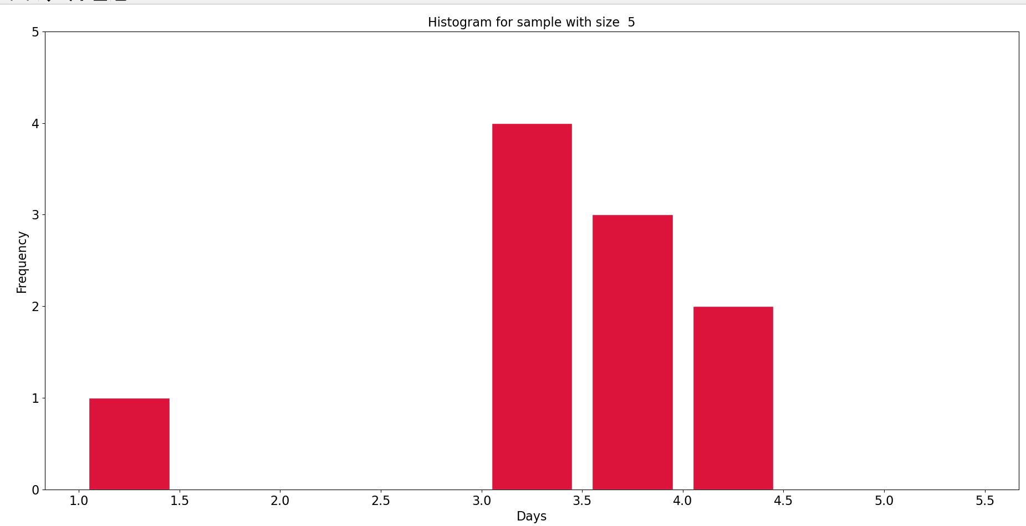
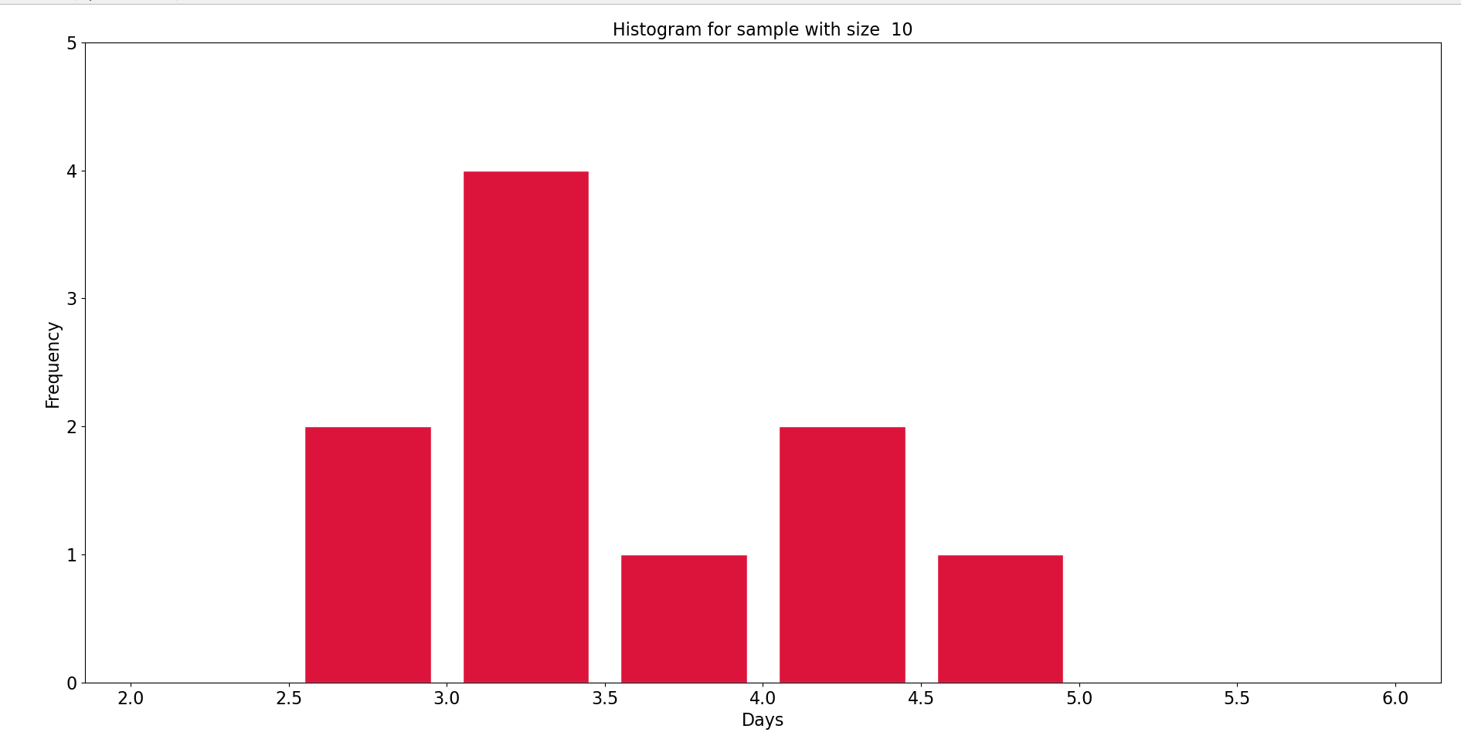

Discussion Questions
- Compare the three histograms you have made, the one for the population and the two for the sample means. In three to five sentences, describe the similarities and differences.
The histogram for the population shows a skewed distribution with a long right tail, indicating that the population is not normally distributed. The histogram for the sample means with a sample size of 5 shows a somewhat more symmetrical distribution than the population, but still exhibits some skewness. Same applies to histogram with size 10. This demonstrates the Central Limit Theorem, which states that the distribution of the sample means becomes more normal as the sample size increases. The larger sample size reduces the impact of outliers and irregularities in the population, resulting in a more normal distribution of sample means.

2. State the theoretical (according to the clt) distributions for the sample means.
n = 5: x̄ ~ N(μ, σ/√5)
n = 10: x̄ ~ N(μ, σ/√10)

- Are the sample means for n = 5 and n = 10 “close” to the theoretical mean, μx? Explain why or why not.
The sample means for n = 5 and n = 10 are close to the theoretical mean, μx, according to the Central Limit Theorem. As the sample size increases, the sample means should become closer to the population mean.
- Which of the two distributions of sample means has the smaller standard deviation? Why?
According to the Central Limit Theorem, as the sample size increases, the standard deviation of the distribution of sample means decreases. Therefore, the distribution of sample means for n=10 should have a smaller standard deviation than the distribution of sample means for n=5.
- As n changed, why did the shape of the distribution of the data change? Use one to two complete sentences to explain what happened.
As the sample size (n) increased, the shape of the distribution of the data became more normal. As a result, the distribution of the sample means becomes less skewed and the spread of the distribution becomes narrower, resulting in a more normal distribution

